**Technical Report**

Interaction Design Course Assignment

Table of Contents

1. Goals
2. Participants
3. Results
4. Fixes & Recommendations
5. **Goals**

Analyze your website and find areas of Improvement, by handing out questionnaires to potential users and comparing competitor’s websites. Identify accessibility issues and look for ways to enhance the user experience.

For example:

* *Evaluate visual interface*
* *UI elements such as button and link size*
* *Font size and typography*
* *Identify overall user satisfaction on accessibility, user interface and interaction*

1. **Participants**

[Provide a description of the participants. Include the number of participants, dates and the number of participants on each testing day.

Provide a summary of the results.  
  
Some Tasks to consider::

**Task 1:**  
Create a new account

**Successful**

Participant opens the app, clicks on the link and completes the steps required to create a new account.

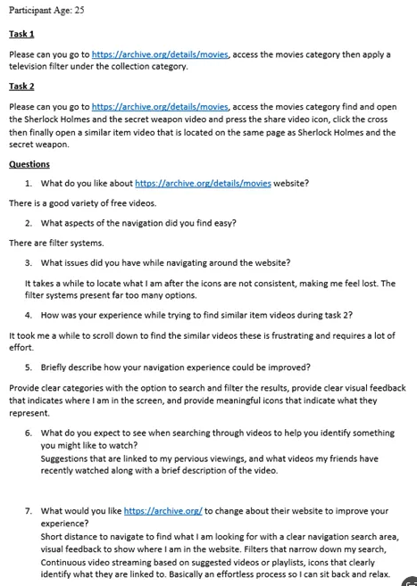

1. **Results**

Describe the results by: explaining any tasks that were successfully completed or any issues participants might have experienced. Also share your Hotjar recordings as CSV, or Heatmap images.

For example:

All participants successfully completed **Task 1** (add product to cart).

Some participants struggled with navigating the website.

It was not easy to find the Contact page.

1. **Bugs / Fixes**

Provide a list of changes driven by the participant success rate, behaviors, and comments. These changes will address the areas where participants experienced problems or found the interface/information architecture unclear. Use the feedback received and test your website again for any final changes.

For example:

User choices - Participants want to change the colours of the buttons. Change colour to comply with color contrast.

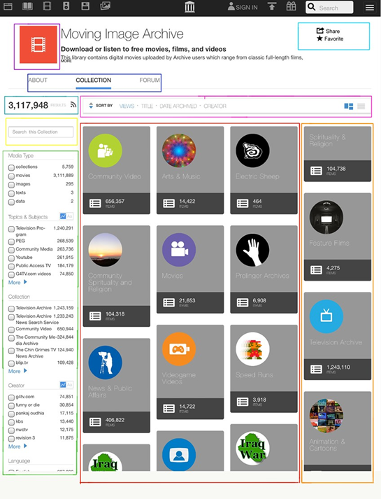

*Highlighted changes*